Character Sheet

---------------------------------------------------------------------------------------

\*Name: Yago Pikachu

+Age: 40

+Weight: 78 kg

+Height: 178 cm

\*Party Affiliation: UFR

\*Personality: Even if you prove your point, he won’t change his position. Loyal.

+Likes: The Crown / The Harrison Dynasty / Patrium

+Dislikes: Guillotine / Jacobins

\*Description(Or Image):

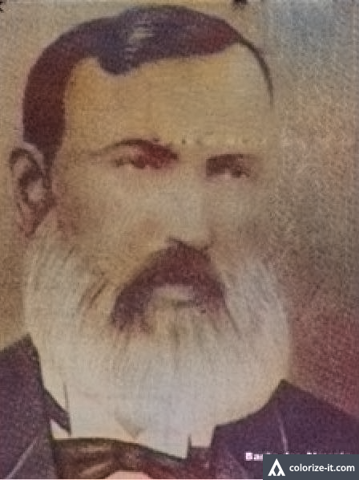

\*Bio: Pikachu was born in the countryside of Patrium later being accepted into a Military School of Catalan learning the basics of warfare. During his stay at the army, he fought as a volunteer in Afghanistan, earning him the Medal of Merit of Patrium. He would travel to GB to learn foreign tactics in an exchange program made by Patrium and GB. There, he noticed the unity and happiness that the brits held towards the Queen. When he arrived in Patrium, he noticed how polarized the country is and understood that if there was a monarch, this problem would not exist. He then started studying how monarchies benefited the entire nation and came to the conclusion that what Patrium was missing, was a constitutional monarchy. The Harrison Dynasty seemed like the fittest for Pikachu. Later on, he noticed that he could only change the country if he participated in politics and then retired off the army to join the UFR.